Programming: Assignment-7: Linux 25-09-2025
1. What is a bash shell script? Give one example.
A Bash shell script is a text file that holds a sequence of commands written for the Bash interpreter to execute. It helps automate everyday tasks, system management, and command sequences so you don’t have to type them repeatedly.
Example:
#!/bin/bash
echo "Hello! Welcome to Bash scripting."
echo "The current date and time is:"
date

2. Write a simple shell script to print “Hello World”.
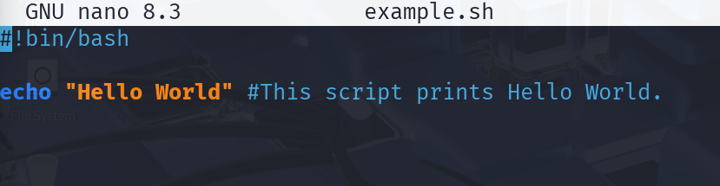


3. What is the purpose of comments (#) in a shell script?
In a shell script, anything written after the # symbol is treated as a comment.
Comments are ignored by the shell; they exist only to explain what the code does, making it easier to read and understand later.

4. How do you declare variables (int, float, double, string, Boolean, and char) in a shell script?
In Bash, variables don’t require explicit data types like in C or Java.
All variables are treated as strings by default, and their type is interpreted based on how they’re used.
Example:
name="Anubhab"
age=20

5. Write a shell script to display the current date and time of the system.
#!/bin/bash
echo "Current Date and Time:"
date

6. Explain the difference between a constant and a variable in bash script.
- A variable is a value that can change during the execution of the script.
- A constant, once assigned, is not meant to be modified while the program runs.
Bash doesn’t have strict constants by default, but you can use readonly to make a variable constant:
readonly name="Linux"

7. Write a shell script to read two integer numbers from the user and compute their sum.
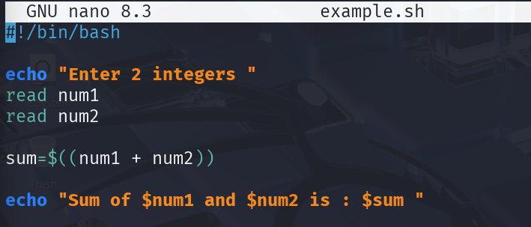

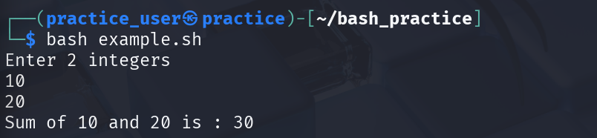

8. What is the use of the source command in shell scripting?
The source command executes a script within the current shell environment.
This means that any variables or functions defined in the sourced script remain available after it runs.
If you simply run bash script.sh, it creates a new shell and any variables are lost once it exits.
However, when using source script.sh, the variables remain active in the current shell.

9. How can you debug a shell script? Give two methods.
Method 1 – Using -x:
Run the script with:
bash -x script.sh
It prints each command before execution, helping trace the script step-by-step.
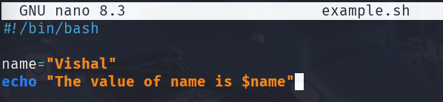
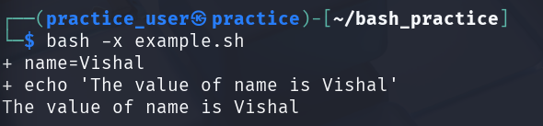
Method 2 – Using -n:
bash -n script.sh
This checks only for syntax errors without running the script. If no output appears, the syntax is correct.

10. Write a bash script to create and delete a file.
#!/bin/bash
# Create a file
touch sample.txt
echo "sample.txt has been created."

# Check and delete
if [ -f sample.txt ]; then
echo "File exists. Deleting it now..."
rm sample.txt
echo "sample.txt has been deleted."
else
echo "File not found."
fi

